Kunsthistorisches Museum

Ahmad Hasan Ahmad

2023-04-27

Table of contents

# 1. Kunsthistorisches Museum

Author: Ahmad Hasan Ahmad

ORCID: https://orcid.org/0009-0008-4964-222X

Date: 28.04.2023

DOI: 10.5281/zenodo.7873444

Repository URL: https://github.com/Ahmad19111/catalogue-003

## 1.1 Based on Baroque AI: Publication Prototype

## 1.2 Part of the series: Baroque TOC

[Programme instructions](https://nfdi4culture.github.io/class-ADA-CP-pipeline/)

2023-03-17

This work is licensed under a Creative Commons Attribution-ShareAlike 4.0 International License.

Book cover: Reworking of [Baroque pearl with enamelled gold mounts set with rubies](https://en.wikipedia.org/wiki/File:Pendant_in_the_form_of_a_siren_MET_DT7173.jpg). Creative Commons CC0 1.0 Universal Public Domain Dedication. This file was donated to Wikimedia Commons as part of a project by the Metropolitan Museum of Art.

This work is licensed under a Creative Commons Attribution-ShareAlike 4.0 International License.

# 2. Colophon

* Fork title: Ahmad19111/catalogue-003
* Author: Ahmad Hasan Ahmad
* ORCID: https://orcid.org/0009-0008-4964-222X
* Date: 28.04.2023
* DOI: 10.5281/zenodo.7873444
* Repositor: https://github.com/Ahmad19111/catalogue-003

PUBLISHING FROM COLLECTIONS USES OF COMPUTATIONAL PUBLISHIGN AND LINKEDOPEN DATA

Open Science Lab - TIB Hannnover

First published 2023-03-30

Copyright © The Authors 2023 Licensed as https://creativecommons.org/licenses/by-sa/4.0/

DOI: https://doi.org/10.5281/zenodo.7701161

# 3. About the Museum

Source: https://de.wikipedia.org/wiki/Kunsthistorisches_Museum_Wien

### 3.0.1 Kunsthistorisches Museum

The Kunsthistorisches Museum (lit. “Museum of Art History”, often referred to as the “Museum of Fine Arts”) is an art museum in Vienna, Austria. Housed in its festive palatial building on the Vienna Ring Road, it is crowned with an octagonal dome. The term Kunsthistorisches Museum applies to both the institution and the main building. It is the largest art museum in the country and one of the most important museums worldwide.

Emperor Franz Joseph I of Austria-Hungary opened the facility around 1891 at the same time as the Natural History Museum, Vienna which has a similar design and is directly across Maria-Theresien-Platz.The two buildings were constructed between 1871 and 1891 according to plans by Gottfried Semper and Baron Karl von Hasenauer. The emperor commissioned the two Ringstraße museums to create a suitable home for the Habsburgs’ formidable art collection and to make it accessible to the general public. The buildings are rectangular, with symmetrical Renaissance Revival façades of sandstone lined with large arched windows on the main levels and topped with an octagonal dome 60 metres (200 ft) high. The interiors of the museums are lavishly decorated with marble, stucco ornamentation, gold-leaf, and murals. The grand stairway features paintings by Gustav Klimt, Ernst Klimt, Franz Matsch, Hans Makart and Mihály Munkácsy.

# 4. Data Visualization

Visualization

Here an image of my data viz 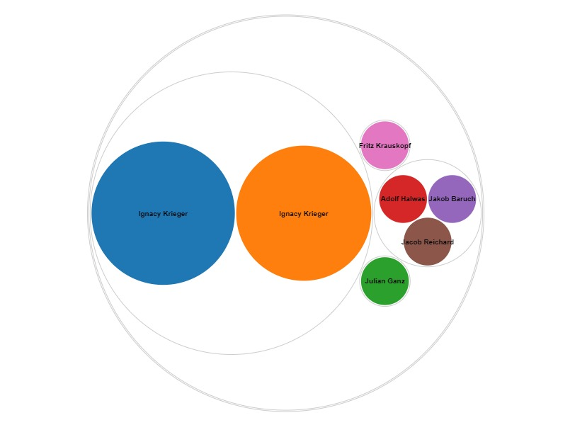

Here is an iframe with some data viz:

# 5. Historischer Porträtaufnahmen

Wikidata link: <http://www.wikidata.org/entity/Q119217955>

Title: Polish Rabbi

Year: 1870-01-01T00:00:00Z

Creator: Ignacy Krieger

Collection: Bpk-Bildagentur

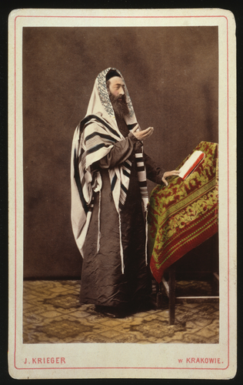

Wikidata link: <http://www.wikidata.org/entity/Q119217956>

Title: Young Pole in national dress from Lublin region

Year: 1870-01-01T00:00:00Z

Creator: Ignacy Krieger

Collection: Bpk-Bildagentur

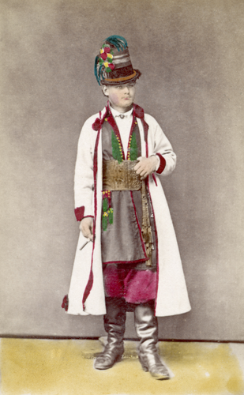

Wikidata link: <http://www.wikidata.org/entity/Q119217957>

Title: Old man from Plotska area

Year: 1870-01-01T00:00:00Z

Creator: Ignacy Krieger

Collection: Bpk-Bildagentur

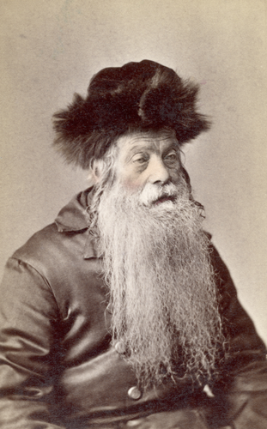

Wikidata link: <http://www.wikidata.org/entity/Q119217958>

Title: Polish couple in national costume

Year: 1870-01-01T00:00:00Z

Creator: Ignacy Krieger

Collection: Bpk-Bildagentur

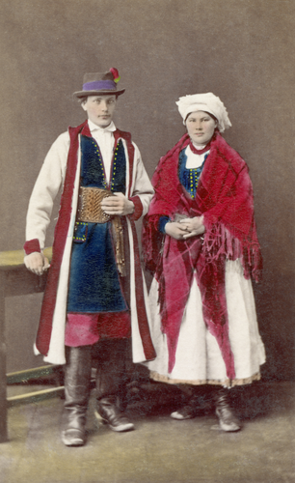

Wikidata link: <http://www.wikidata.org/entity/Q119217959>

Title: Male costume from the Lublin area

Year: 1870-01-01T00:00:00Z

Creator: Ignacy Krieger

Collection: Bpk-Bildagentur

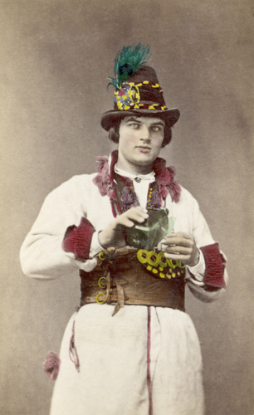

Wikidata link: <http://www.wikidata.org/entity/Q119217961>

Title: children’s costume

Year: 1870-01-01T00:00:00Z

Creator: Ignacy Krieger

Collection: Bpk-Bildagentur

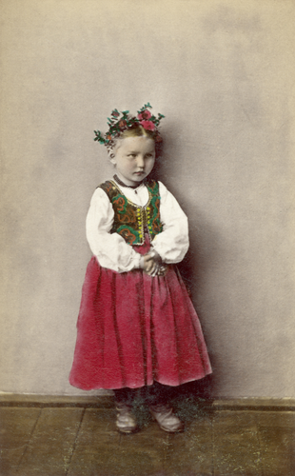

Wikidata link: <http://www.wikidata.org/entity/Q119217962>

Title: women’s costume

Year: 1870-01-01T00:00:00Z

Creator: Ignacy Krieger

Collection: Bpk-Bildagentur

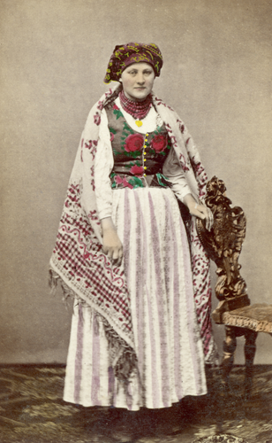

Wikidata link: <http://www.wikidata.org/entity/Q119217987>

Title: Couple in Sunday costume

Year: 1870-01-01T00:00:00Z

Creator: Ignacy Krieger

Collection: Bpk-Bildagentur

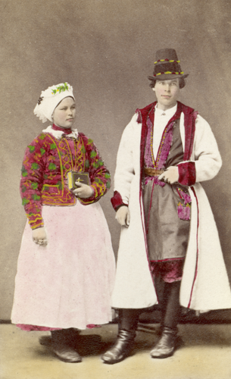

Wikidata link: <http://www.wikidata.org/entity/Q119224407>

Title: Couple in holiday costume

Year: 1870-01-01T00:00:00Z

Creator: Ignacy Krieger

Collection: Bpk-Bildagentur

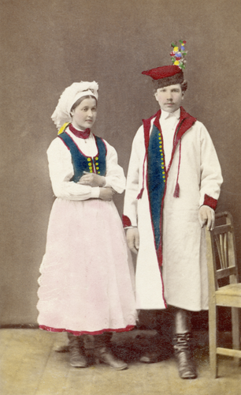

Wikidata link: <http://www.wikidata.org/entity/Q119224408>

Title: Festival costume of a young farmer

Year: 1880-01-01T00:00:00Z

Creator: Ignacy Krieger

Collection: Bpk-Bildagentur

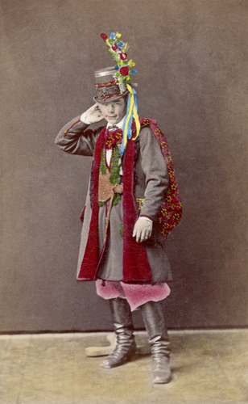

Wikidata link: <http://www.wikidata.org/entity/Q119224410>

Title: Clothes of a landowner from the Lublin area

Year: 1880-01-01T00:00:00Z

Creator: Ignacy Krieger

Collection: Bpk-Bildagentur

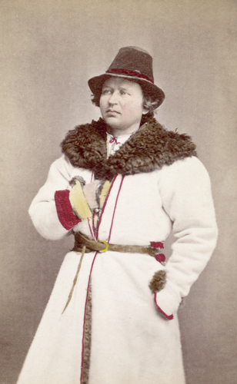

Wikidata link: <http://www.wikidata.org/entity/Q119224411>

Title: Itinerant saleswoman with wall mats

Year: 1880-01-01T00:00:00Z

Creator: Ignacy Krieger

Collection: Bpk-Bildagentur

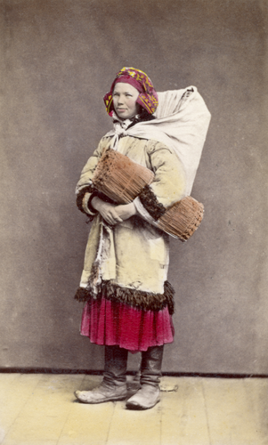

Wikidata link: <http://www.wikidata.org/entity/Q119224412>

Title: Costume of a Warsaw student

Year: 1880-01-01T00:00:00Z

Creator: Ignacy Krieger

Collection: Bpk-Bildagentur

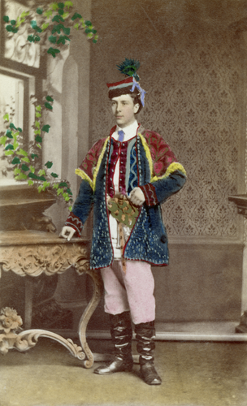

Wikidata link: <http://www.wikidata.org/entity/Q119224414>

Title: Coachman’s clothing

Year: 1880-01-01T00:00:00Z

Creator: Ignacy Krieger

Collection: Bpk-Bildagentur

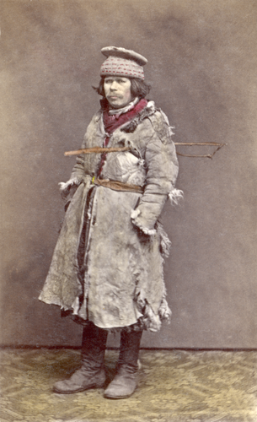

Wikidata link: <http://www.wikidata.org/entity/Q119224417>

Title: Costume of a peasant girl

Year: 1880-01-01T00:00:00Z

Creator: Ignacy Krieger

Collection: Bpk-Bildagentur

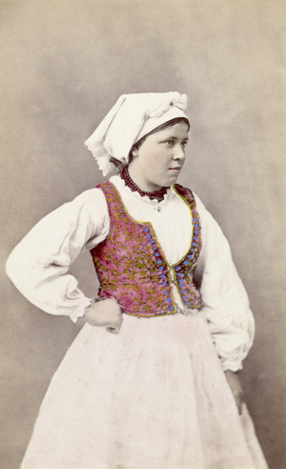

Wikidata link: <http://www.wikidata.org/entity/Q119224419>

Title: Shepherd’s costume

Year: 1880-01-01T00:00:00Z

Creator: Ignacy Krieger

Collection: Bpk-Bildagentur

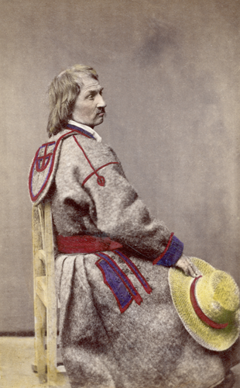

Wikidata link: <http://www.wikidata.org/entity/Q119224499>

Title: costume of a farmer

Year: 1880-01-01T00:00:00Z

Creator: Ignacy Krieger

Collection: Bpk-Bildagentur

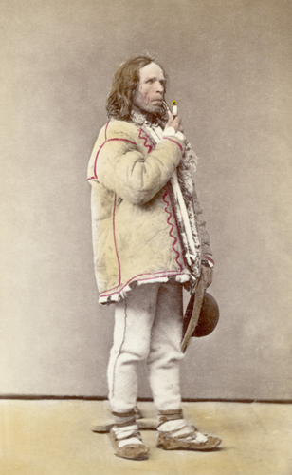

Wikidata link: <http://www.wikidata.org/entity/Q119224500>

Title: David Popper

Year: 1873-01-01T00:00:00Z

Creator: Julian Ganz

Collection: Bpk-Bildagentur

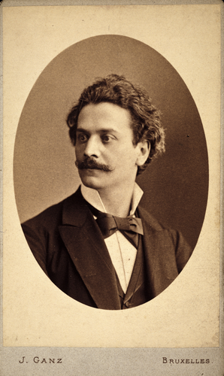

Wikidata link: <http://www.wikidata.org/entity/Q119224502>

Title: Max Bruch

Year: 1895-01-01T00:00:00Z

Creator: Adolf Halwas

Collection: Bpk-Bildagentur

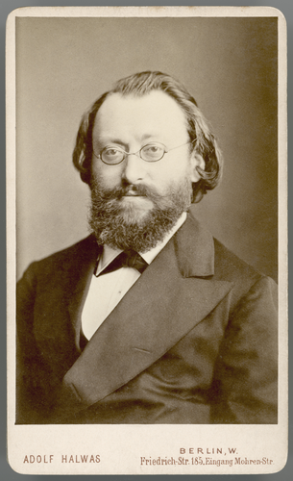

Wikidata link: <http://www.wikidata.org/entity/Q119224503>

Title: Gerhart Hauptmann

Year: 1889-01-01T00:00:00Z

Creator: Jakob Baruch

Collection: Bpk-Bildagentur

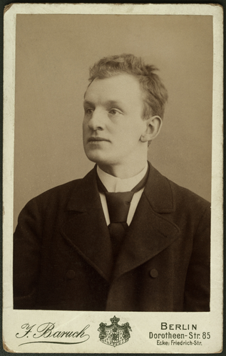

Wikidata link: <http://www.wikidata.org/entity/Q119224504>

Title: Hermann Ludwig Ferdinand von Helmholtz

Year: 1881-01-01T00:00:00Z

Creator: Jacob Reichard

Collection: Bpk-Bildagentur

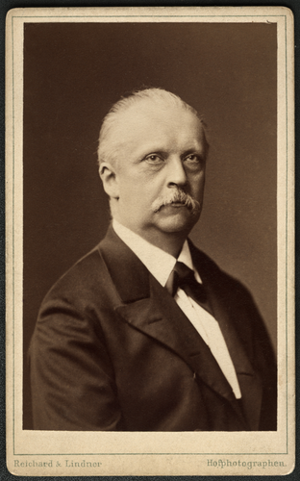

Wikidata link: <http://www.wikidata.org/entity/Q119224506>

Title: “Old gentleman” with student cap

Year: 1910-01-01T00:00:00Z

Creator: Fritz Krauskopf

Collection: Bpk-Bildagentur

